The Abbeyfield Society Arts Project – Golden Galleries

The Abbeyfield Society launched a series of art exhibitions called ‘Golden Galleries’ in 2016 to showcase the work created by older people living in the care of Abbeyfield homes and houses across the country. The initiative is a celebration of older people who are as unique and individual as the artwork they have created.
The aim of the exhibitions is to highlight the important therapeutic benefits art brings to older people, providing a means of expression particularly for those living with dementia and/or other medical conditions. We also want to challenge people’s perceptions and encourage everyone to look past the condition and at the individual instead.
We worked with the National Alliance for Museums, Health and Wellbeing to identify museums and galleries who were willing to lend us space within their prestigious sites to exhibit the work of our residents. In May this year, during dementia awareness week, we held a gallery at the Beamish Museum in Durham. Currently we have a large exhibition at the Birmingham Museum and Gallery, and in mid October, the gallery moves to the premises of Nottingham City Arts, and then on to our head office in St Albans.
We left a visitor book for people to write their comments in at the Birmingham gallery;
“Beautiful and inspiring. People in care homes are still people with feelings and talent”
“So glad that such great work is being displayed for all to admire”
“I had an excellent visit with my dad and the pictures made him smile”
“It is the most touching and beautiful exhibition in the museum”

Making a difference

We’ve seen that the creative process transports people into a happier place. It boosts self esteem and well being, unlocks memories and brings people together. Here are a few examples;
A stroke left 75 year old Rex unable to speak or walk and with paralysis of his left side. It also left him with vascular dementia. Rex moved into an independent living apartment with Abbeyfield and was encouraged to paint by the staff and his family. He began creating a variety of paintings from landscapes to family portraits. His confidence soared.

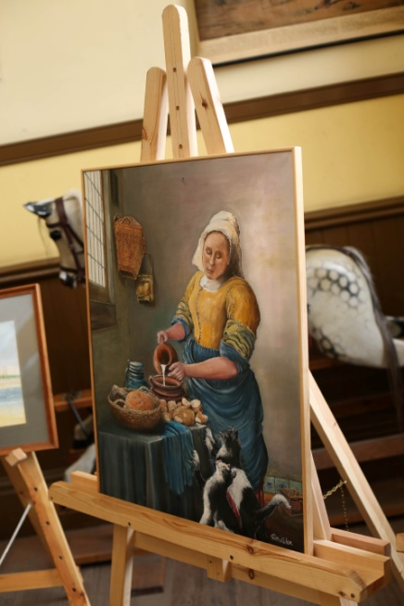 A painting by Rex copied from a famous Vermeer

Eileen, who lives in an Abbeyfield care home, painted a picture from a photograph of a day trip she went on with her late husband. Eileen was transported right back to that day which she holds very dear to her heart.

Ethel is registered blind and never had an interest in art or craft work until she was encouraged to participate in art sessions organised by the house volunteer. Ethel experimented with a variety of materials and has a particular interest in drawing landscapes and animals. She remembered visiting Mussenden Temple, a popular tourist attraction on the North Coast of Northern Ireland and recreated it using chalk and pencil.

What did we learn through the project?

Caring for the ‘whole person’
We learnt that our staff have a vital role to play in supporting and enabling people to take part in creative arts. We witnessed how art can promote emotional well being by giving focus and a vehicle for expression, and how it helps people to maintain and improve dexterity which helps with daily living skills. We also saw how those taking part felt uplifted through the use of colours and witnessed a lifting of mood and a reduction in anxiety and depression.

Inclusivity
Art is inclusive. We received submissions from a wide range of older people including those who are unable to leave their beds, people with all forms of physical and mental health conditions and those who usually would not take part in any ‘group’ activity. Many people have lost partners and feel lonely – working on collaborative projects brought people together. Art takes many forms – there’s something for everyone.

Learning new skills
We were reminded that older people enjoy learning new skills. Residents at an Abbeyfield day centre for people with dementia used i pads to create their art saying that using the ipad gave a ‘freedom of expression’.

What do residents and their families say about the use of the arts?

One resident from Tavistock was inspired to complete a tapestry started by his wife who sadly died after completing only a small section of the border. He said “it took me some months but it was very creative and very satisfactory”. He added that he finished it “to honour her memory”

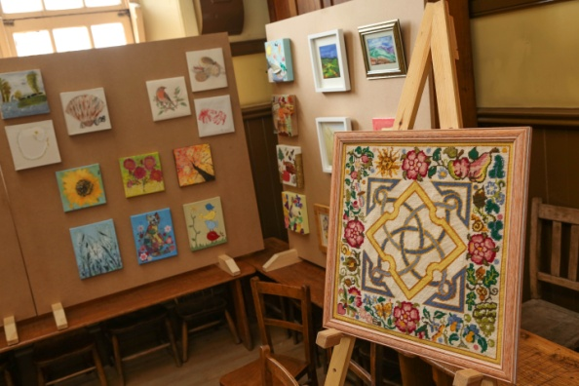Tapestry by Michael in Tavistock

The daughter of an Abbeyfield resident at a home in Newcastle said: “People think that when you go into residential care you have to give everything up, but my mum is proof that it doesn’t have to be like that. The staff at Abbeyfield have helped to nurture and encourage Mum. They know she finds group conversations difficult so they have helped her enjoy her painting which keeps her occupied and gives her a sense of purpose. Instead of watching daytime television, I know she is enjoying her painting which continues to be such an important part of her life. Mum’s art has become a conversation starter. We can talk about colours and about what we can see looking out of the window and how mum has interpreted it. It gives us something new to share and talk about.
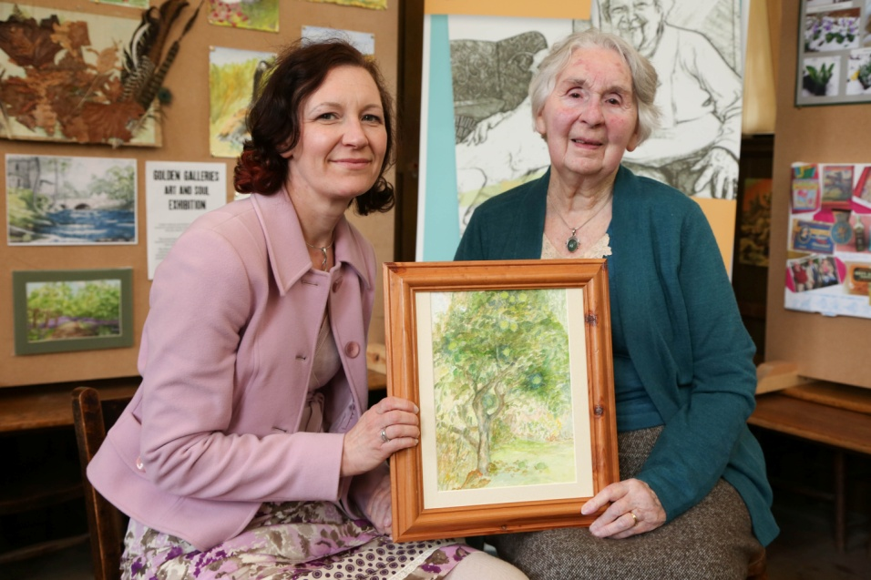 Winifred and her daughter with a watercolour by Winifred

Abbeyfield is a charity which was founded 60 years ago by Major Richard Carr-Gomm with the aim of alleviating loneliness in older people and improving their quality of life. That ethos continues today with over 8000 older people enjoying life in a supported, family-like atmosphere Abbeyfield provides in its houses and specialist care homes across the UK and beyond.

This is a very special initiative that has united Abbeyfield homes and houses and raised the bar in terms of how residents are supported and engaged in an occupation that brings them joy.
Alongside the obvious health and well- being benefits, ‘Golden Galleries” has provided a sense of purpose and recognition for our residents, volunteers and staff members.

In the coming months, in partnership with the Birmingham Museum and Gallery, we are providing opportunities for older people to visit our exhibition and try different creative activities for free and, of course, to view the beautiful collections housed at the gallery.

We made a film about the “Golden Galleries” initiative which can be viewed here https://www.youtube.com/user/TheAbbeyfieldSociety and produced a gallery ‘brochure’ for residents. We also have an ‘on line gallery’ where the work of all our residents can be viewed at http://www.abbeyfield.com/golden-galleries/

April Dobson
Head of Dementia Innovation – The Abbeyfield Society

