Arteffact

Can creative engagement in museums improve the mental health and wellbeing of people experiencing mental distress?

Report summary

A partnership of four museums and galleries in North Wales has developed a project to deliver art sessions within the museum and gallery environment to people who have a history of mental health problems or are experiencing an episode of stress. A research study was run alongside in 2011-12 to answer the question ‘Can creative engagement in museums improve the mental health and wellbeing of people experiencing mental distress?’ This is about distinguishing between creative activities that take place in a medicalised or community day centre setting and those that are delivered in a museum context using museum collections as a stimulus.
Eight groups of 5 – 10 participants experienced a series of arts-based workshops lasting up to 10 weeks in four museum sites in Anglesey, Gwynedd, Conwy and Denbighshire in North Wales. All workshop activity was designed to support the needs of people at risk of or recovering from mental distress and to promote mental wellbeing. This was a mixed methods pilot study. The main focus was on the qualitative elements of the evaluation, with interviews extracting the key themes that influence the effect of the intervention, its acceptability and the feasibility of methods for a larger scale trial. By running some quantitative measures (Warwick Edinburgh Mental Well Being Scale WEMWBS) alongside at baseline and as participants finish the programme we have been able to get some pilot data not only on how these measures behave in this population, but also the acceptability of the measures themselves.
The results of the WEMBS questionnaire show an increase in mean from baseline to follow-up of 8.097 which is significant to p<0.001. Qualitative data show that participants experienced immediate changes to their mental wellbeing as a result of the art activity. The results show a change in many of the common symptoms of depression, anxiety and stress. The immediate effects reported were enjoyment, (it is) absorbing, relief from physical pain, (it) takes mind off problems, calming, healing, therapeutic, relaxing, gives structure to life. Some participants reported a number of long term benefits such as feeling better, increased confidence, increased ability to accept praise, stimulated self-motivation, increased awareness, increased ability to deal with problems, something to live for, making plans for the future and a desire to give something back. Social interaction was a major theme emerging from the findings expressed in terms of engagement/isolation, group dynamics, group supporting each other, fun and independence. There was also an impact on the participants’ attitude to art, there was a movement from being overwhelmed and having issues about artistic ability to an increase in confidence in artistic ability and a sense of ownership and delight in new experience, sense of achievement at learning new skills. Some experienced art as a leveller recognising each was an individual with their own problem and level of artistic ability.
Participants responded to the museum setting and reported it as inspirational and calming, they found that there were a variety of things to stimulate interest, there was lots of space for them to work in. They felt privileged to be able to enjoy such beautiful surroundings, often when the museums were closed to the public, but also responded to it being a public space by interacting with the visitors and experienced a sense of attachment to it. Many experienced an increased awareness as a result of spending time in such a visually rich environment. Engagement with the museum collections supported the participants to make connections between the past and present, meaning their own personal histories and the collective history, thus helping them orientate themselves and gain a sense of perspective. Participants also reported that they experienced a connection to the human through interaction with the artefacts, often experiencing an emotional response that caused them to reflect on their own situations. Some experienced a negative effect in response to the museum setting, this varied from being overwhelmed or distracted to an aggravation of mental state.
The findings of this study indicate that creative activity in museum has a significant beneficial effect on the mental wellbeing of people suffering from mental distress and that the museum setting has contributed to this effect. Further research is needed and the partnership of museums in the Arteffact project provides a strong foundation upon which a larger scale study can be supported.

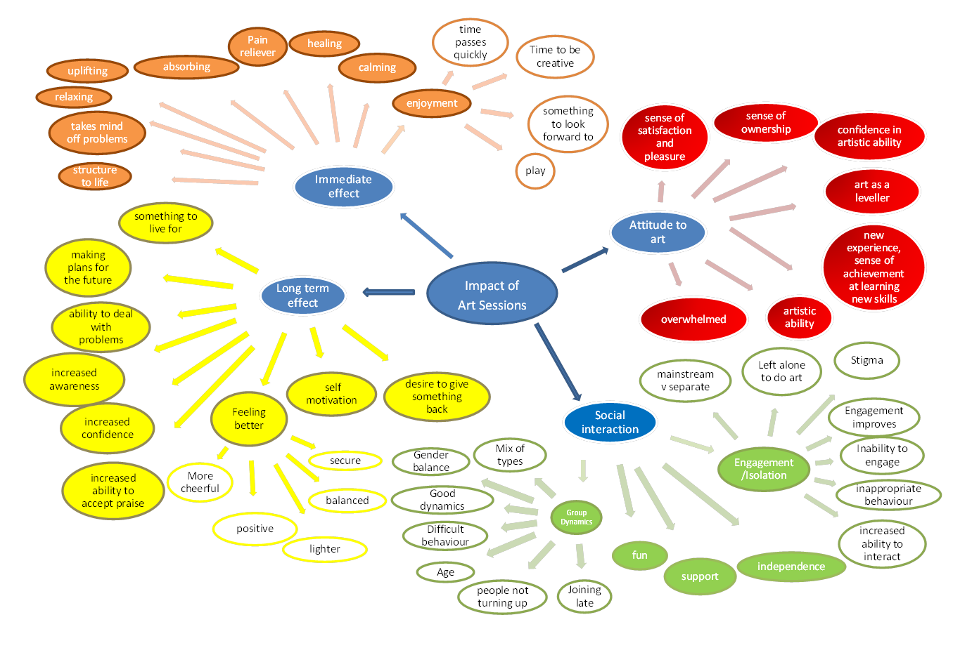

______________________________________________________________________________________________________________
Arteffact is supported financially by CyMAL: Museums, Archives, Libraries Wales (Welsh Government), Bodelwyddan Castle Trust, Gwynedd Art Service (Gwynedd Council), Conwy Art Service (Conwy Council) and Oriel Ynys Môn. Guidance and advice has been generously given by Betsi Cadwaladr University Health Board.

